Homework 01

Philip Hasse

9/20/16

**Solution to 1.4(a) & 1.4(b):**

* After 13 attempts the perceptron was able to separate the two sets of data

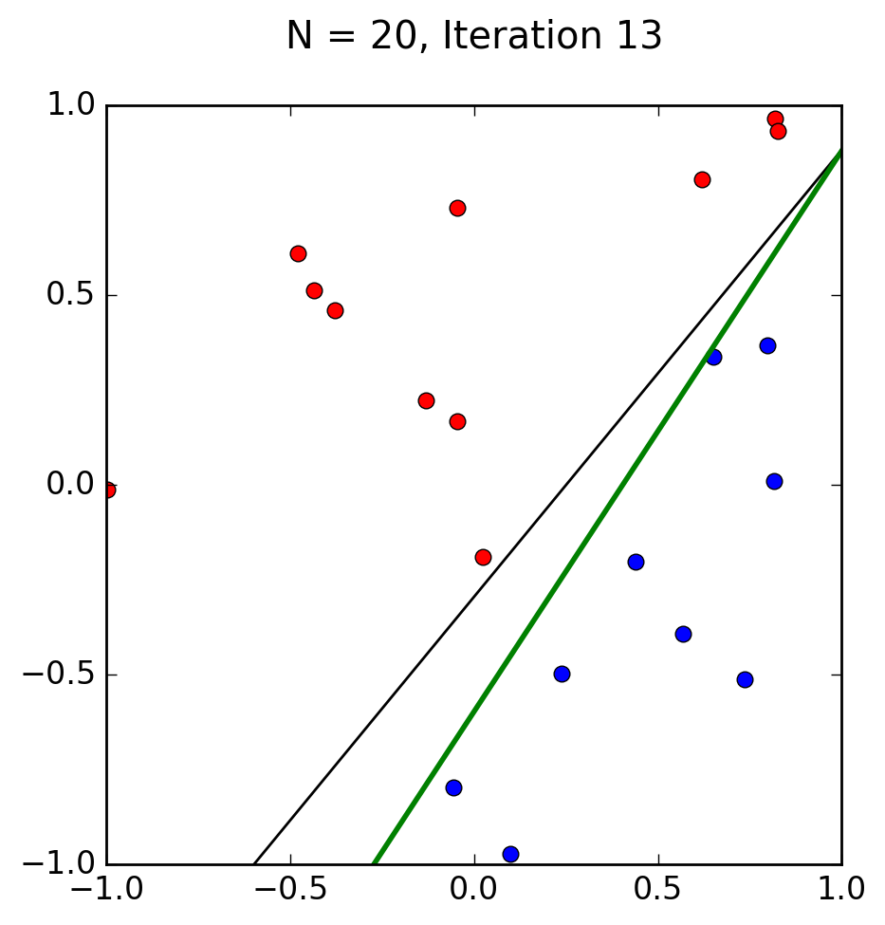

* The solution the perceptron gave (the green line) is not the same as the original solution that we found, however is still an acceptable solution for the data given

**Solution to 1.4(c):**

* After 19 attempts the perceptron was able to separate the data into two parts

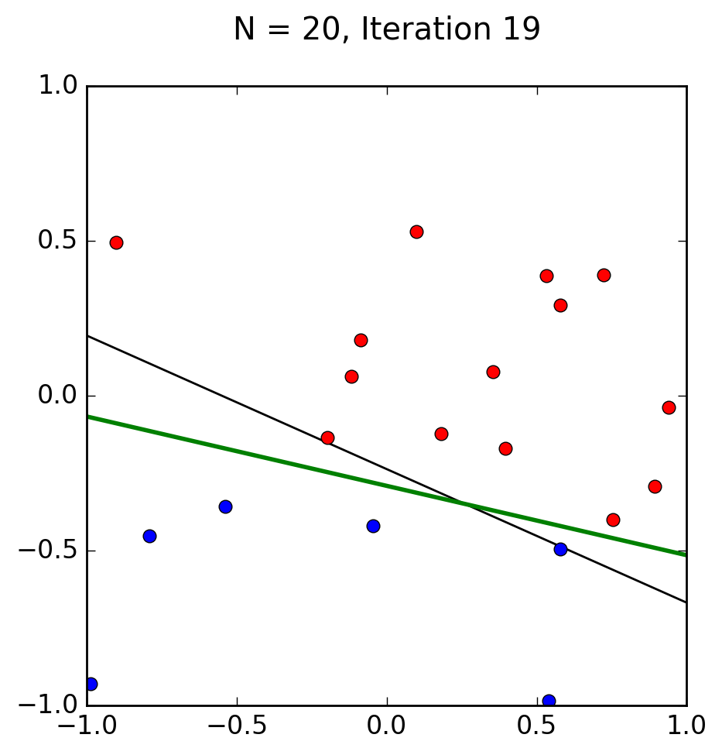

* The solution the perceptron gave is not the same as the original solution; however it still separates the data sets correctly.
* This solution is very similar to part (b) but with a different set of 20 points

**Solution to 1.4(d):**

* After 67 attempts the perceptron was able to separate the data set into two parts

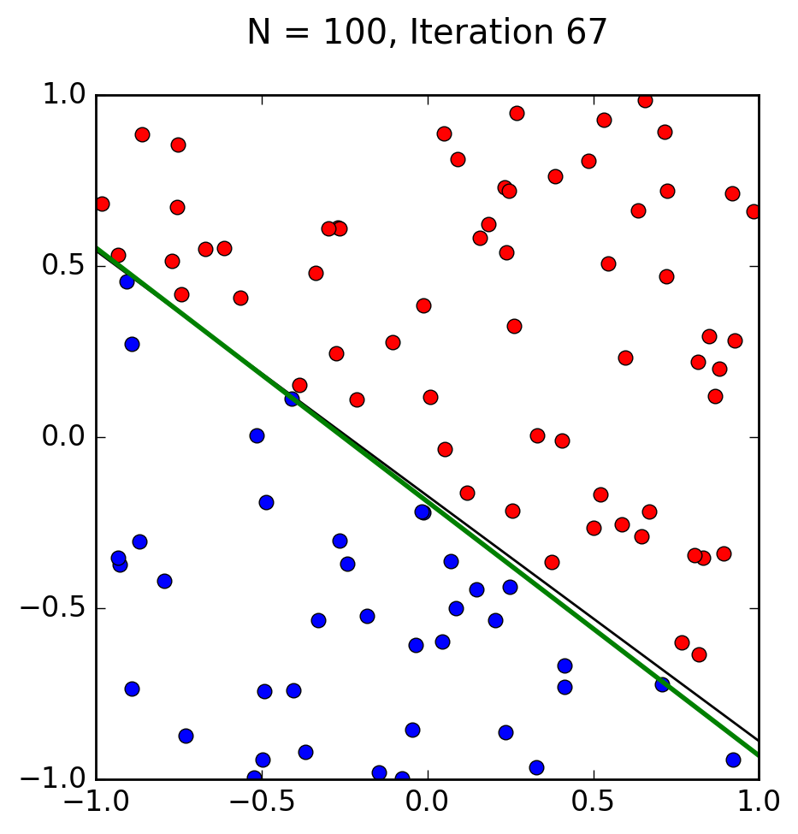

* The perceptron’s solution isn’t the same as the original solution; however it still separates the data sets correctly
* This solution is much closer to the original hypothesis in comparison to part (b) because there are less possible solutions to this data set

**Solution to 1.4(e):**

* After 955 attempts the perceptron was able to separate the data set into two parts

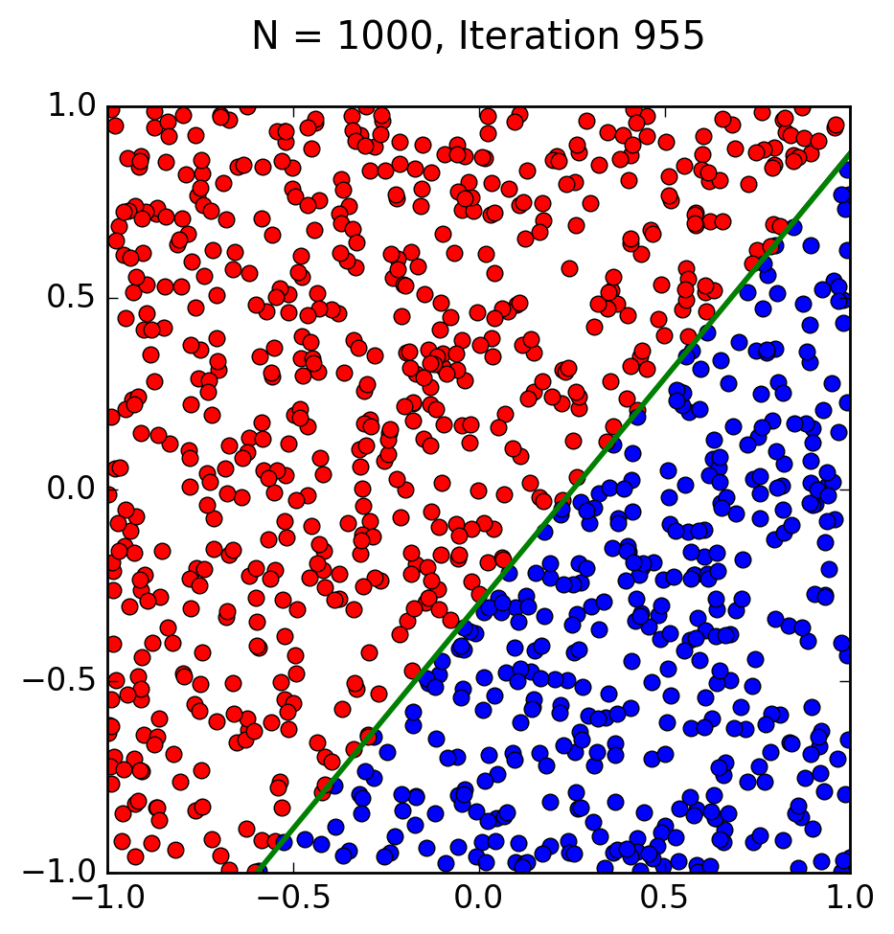

* The perceptron is the closest to the original solution when compared to the other two.
* This solution is much closer, almost identical, to the hypotheses than in parts (b), (c), and (d) because there are much more data points than the solutions prior, which means fewer possible solutions

**Solution to 1.4(f):**

* The perceptron in 10 dimensions took 3689 attempts in order to find the solution

**Solution to 1.4(g):**

* The perceptron varied a from around ~2000 to around ~14000

**Solution to 1.4(h):**

* As running time increases the accuracy of the perceptron increases
* D = 2N